Phase 2 – Performance Testing
Automation Logic

Description
The automation logic is implemented using ServiceNow Flow Designer to streamline the complete lifecycle of network service requests. The flow is triggered upon Service Catalog item submission and performs dynamic actions such as capturing catalog variables, creating records, routing approvals, sending notifications, and updating request status automatically. This ensures consistency, transparency, and minimal manual intervention throughout the process.

Resources
Subtasks (4)

Activity 1: Creation of Flow
Description
- Navigate to Flow Designer from the Application Navigator.
- Click New to create a new flow.
- Provide the Flow Name as Network Request.
- Enter an appropriate description for the flow.
- Click Build Flow to proceed with configuration.
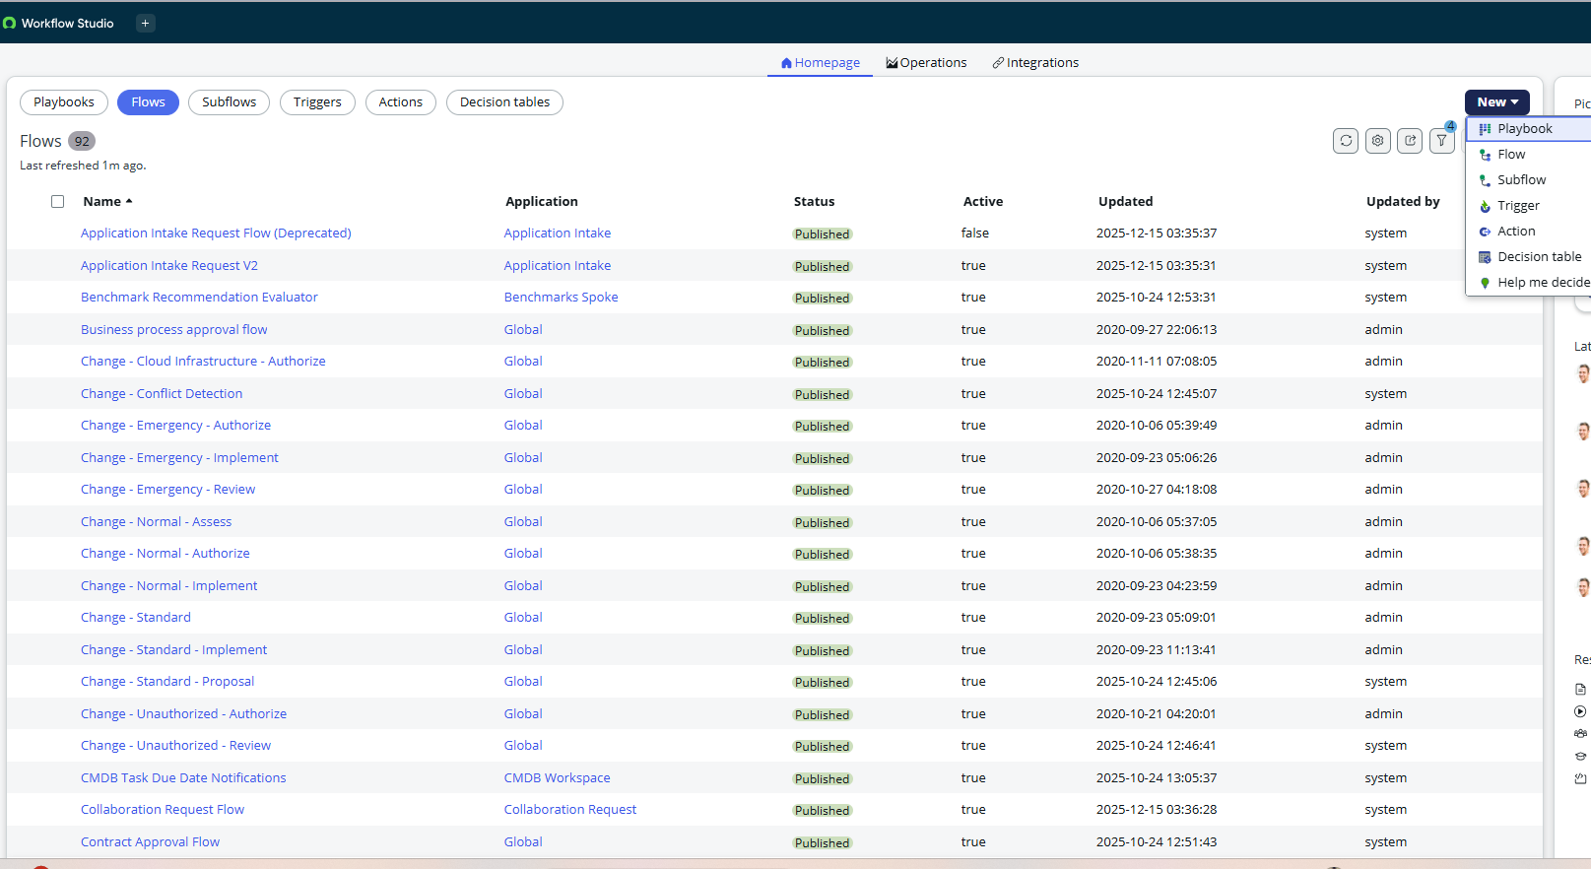

Activity 2: Configuring Trigger
Description
- Click on the ( + ) icon to configure the trigger.
- Select Application → Service Catalog as the trigger type.
- Choose the appropriate catalog item.
- Click Done to save the trigger configuration.
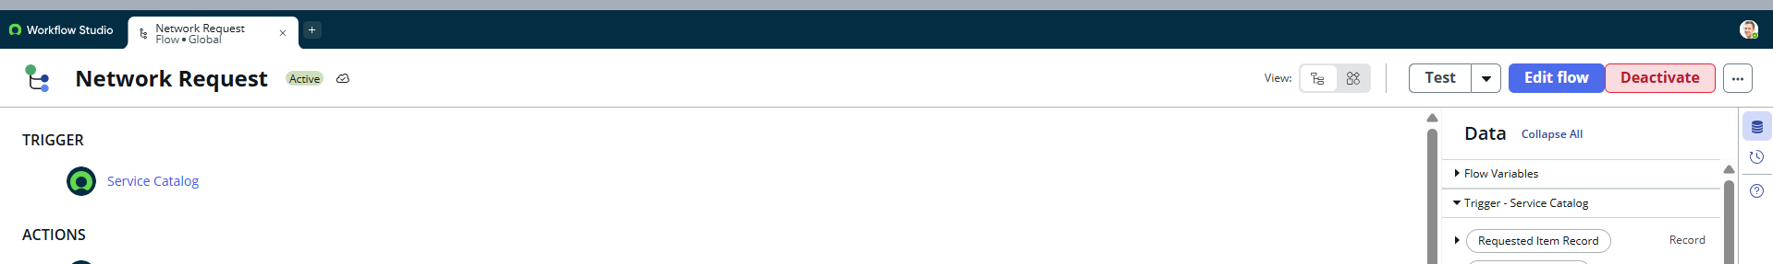

Activity 3: Configuring Actions
1. Get Catalog Variables
Description
- Click Add Action and search for Get Catalog Variables.
- Select the Get Catalog Variables action.
- Configure inputs:
  - Trigger → Service Catalog → Requested Item
  - Template Catalog Items → Select table → Network Request
- Select required variables and move them to the selected list.
- Click Done.

2. Create Record
Description
- Select Create Record action.
- Choose Table as Network Database.
- Click Add Fields to map catalog variables to table fields.
- Configure required fields as per design.
- Click Done.
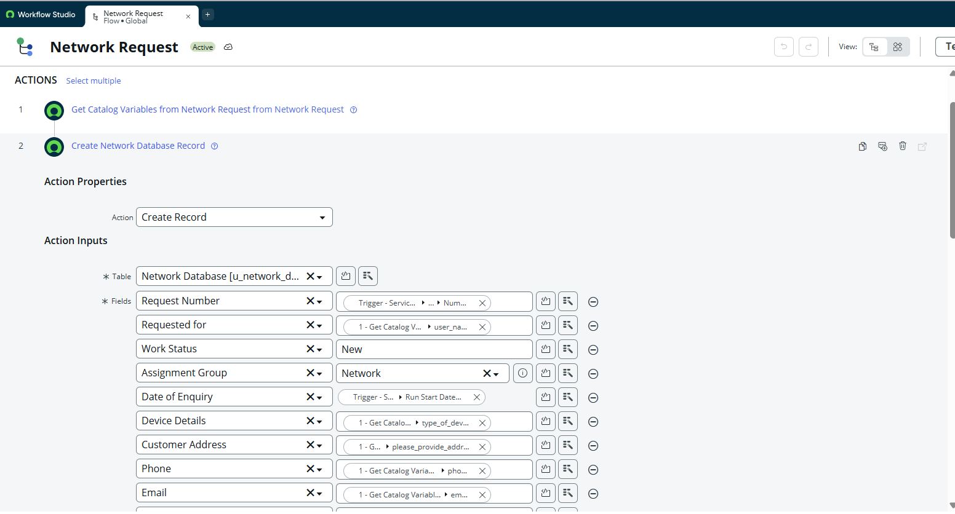

3. Send Email
Description
- Select Send Email action.
- Set Target Record → Create Record → Network Database.
- Table will be auto-selected.
- Configure To, CC, and BCC (static or dynamic).
- Provide Email Subject and Body.
- Click Done.
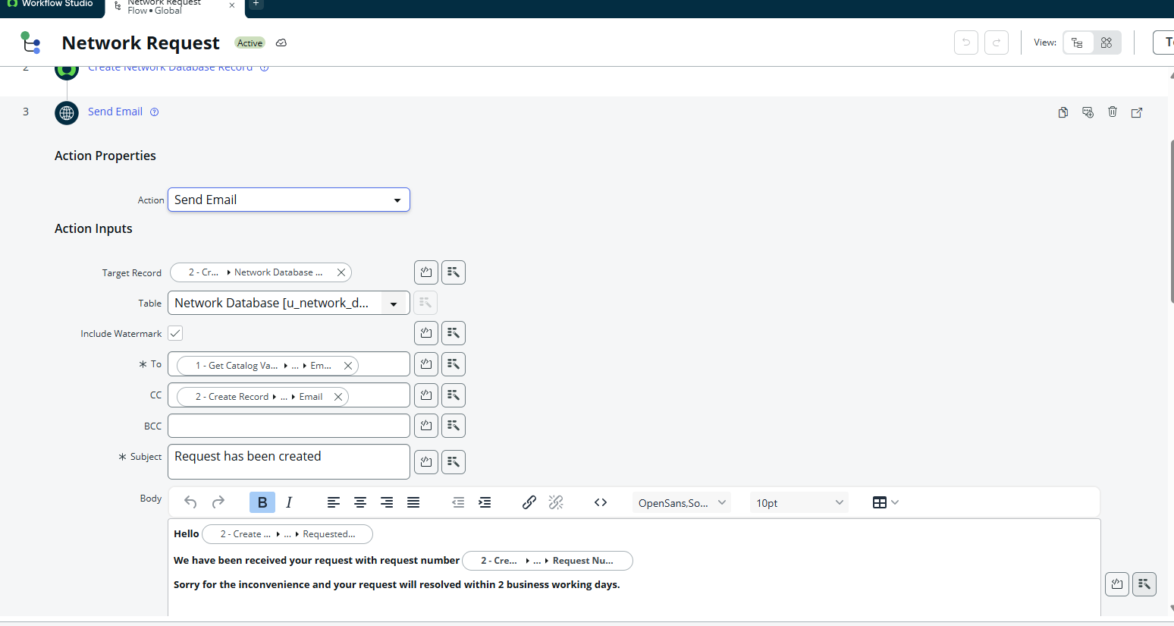

4. Ask for Approval
Description
- Select Ask for Approval action.
- Set Target Record → Create Record → Network Database.
- Provide Approval Reason (e.g., Waiting for approval).
- Configure approval rules:
  - Approve
  - Reject
  - Approve / Reject
- Select approval logic such as Anyone Approves, or Everyone Approves.
- Configure approvers (static or dynamic).
- Click Done.

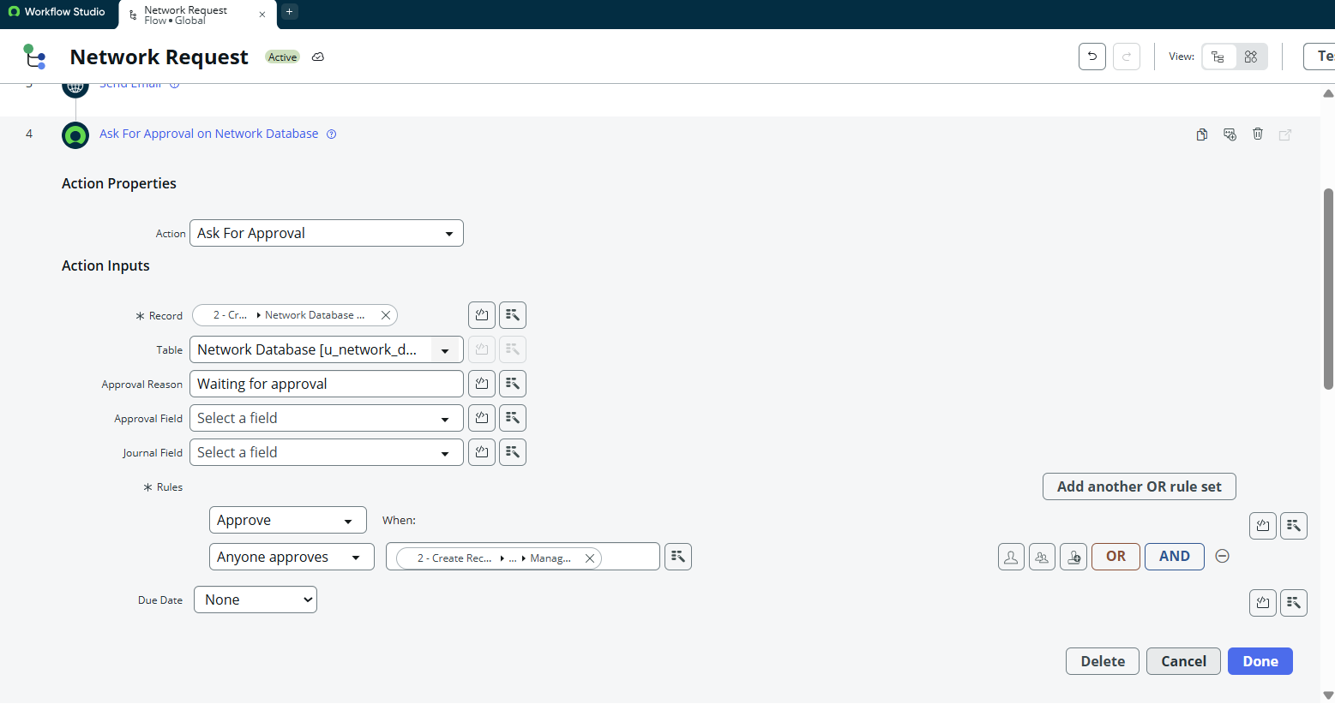

5. Flow Logic (Conditional Routing)
Description
- Add Flow Logic → If condition.
- Apply condition based on Approval State (Approved / Rejected).
- Configure subsequent actions based on outcome.
- Click Done.
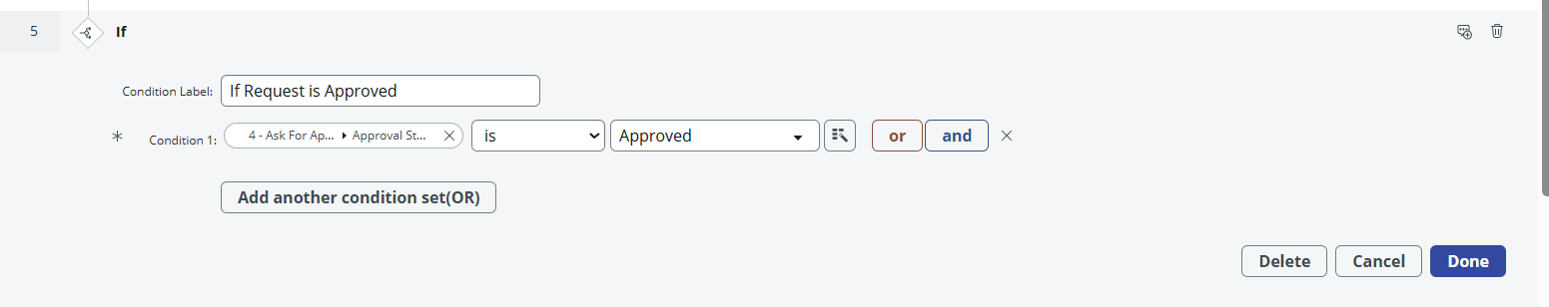
6. Update Record
Description
- Select Update Record action.
- Choose Record → Create Record → Network Database.
- The table will be selected automatically.
- Update fields such as status or approval result.
- Click Done.
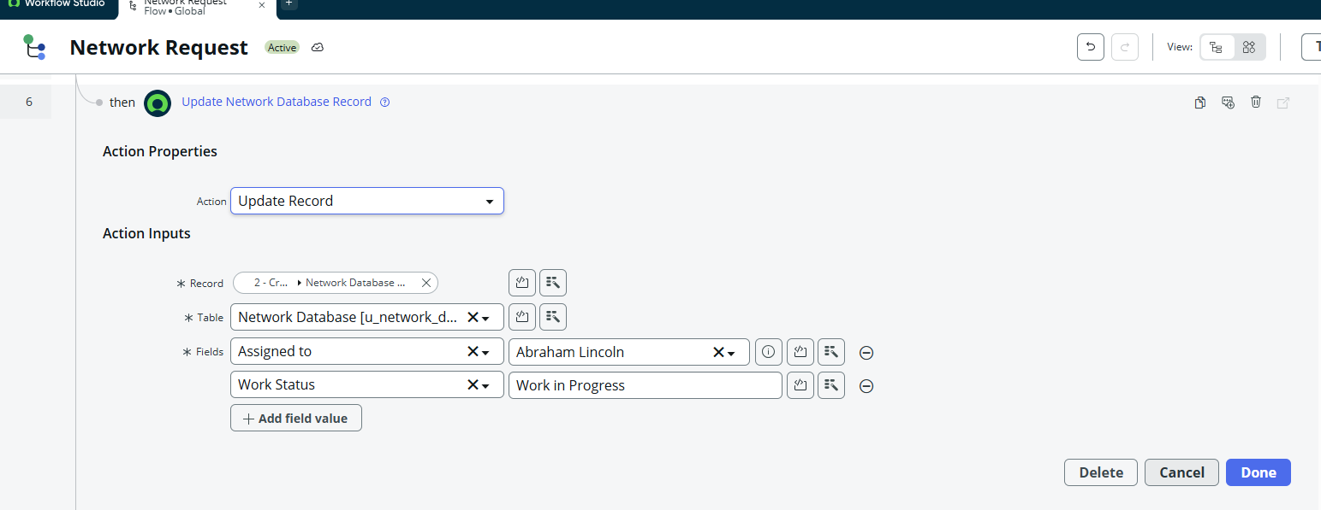

Activity 4: Flow Chart
Description
A detailed flow chart is created to visually represent the automation sequence, including trigger points, decision conditions, approvals, notifications, and record updates. This ensures clarity, maintainability, and ease of future enhancements.
